ADS Assignment 2 Report
Student: Bazarov Zhanserik
Group: BDA – 2503
Github link: https://github.com/zhanssss/ADS-Assignments/tree/master/Assignment-2

Part 1. Logical Data Structures

Task 1. Bank Account Storage Using LinkedList

Create a class BankAccount containing:

• accountNumber

• username

• balance

Create a LinkedList to store accounts.

Program must allow user to:

• Add a new account

• Display all accounts

• Search account by username
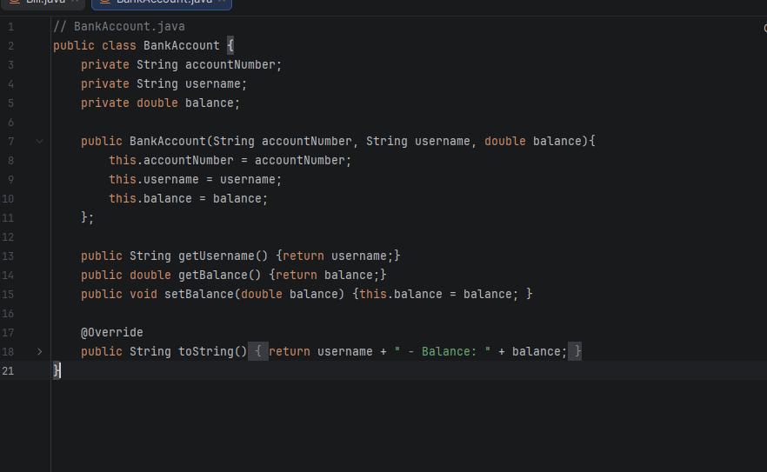

Implemented a BankAccount class and used a LinkedList to store account objects. This choice of data structure allows for efficient dynamic memory management and linear search operations by username.

Task 2 – Deposit & Withdraw Operations

Extend Task 1 program to allow:

• Deposit money

• Withdraw money

• Update balance inside LinkedList
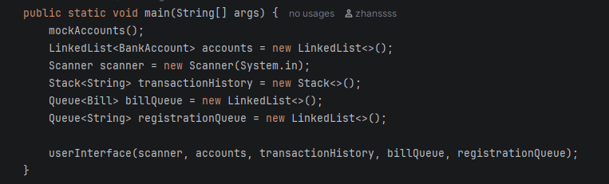
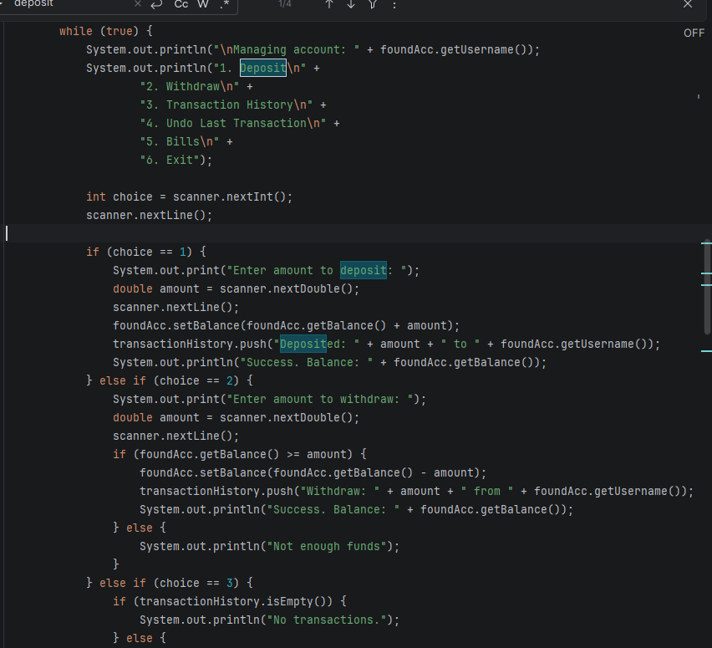
Developed methods to perform financial operations, ensuring that the balance field within the LinkedList objects is updated in real-time after each deposit or withdraw.

Task 3 – Transaction History (Stack – LIFO)
Create a Stack<String> transaction History
Store actions:
- Deposit
- Withdraw
- Bill payment
Program must allow:
- Add transaction to stack
- Undo last transaction (pop)
- Display last transaction (peek)
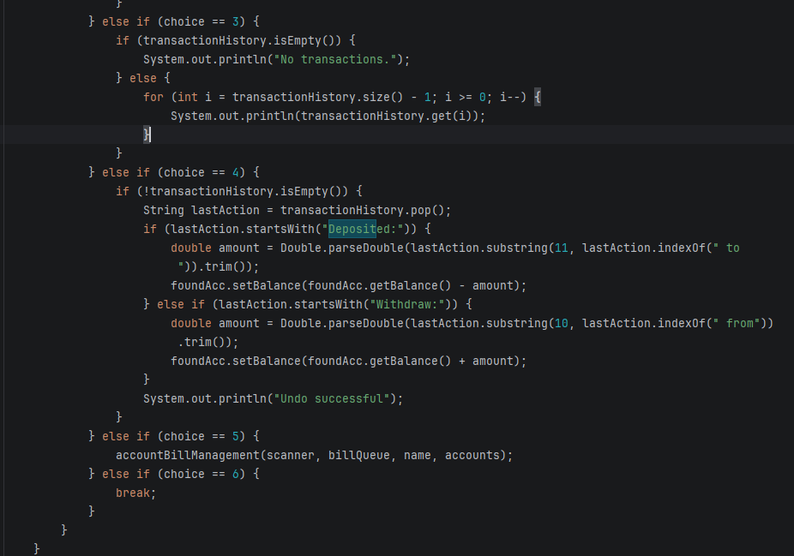

Utilized a Stack to record all account activities. The Last-In-First-Out (LIFO) property of the stack was specifically used to implement an "Undo" feature, allowing the reversal of the most recent transaction.

Task 4 – Bill Payment Queue (Queue – FIFO)

Create a Queue billQueue using LinkedList.

Allow user to:

• Add bill payment request

• Process next bill payment

• Display queue

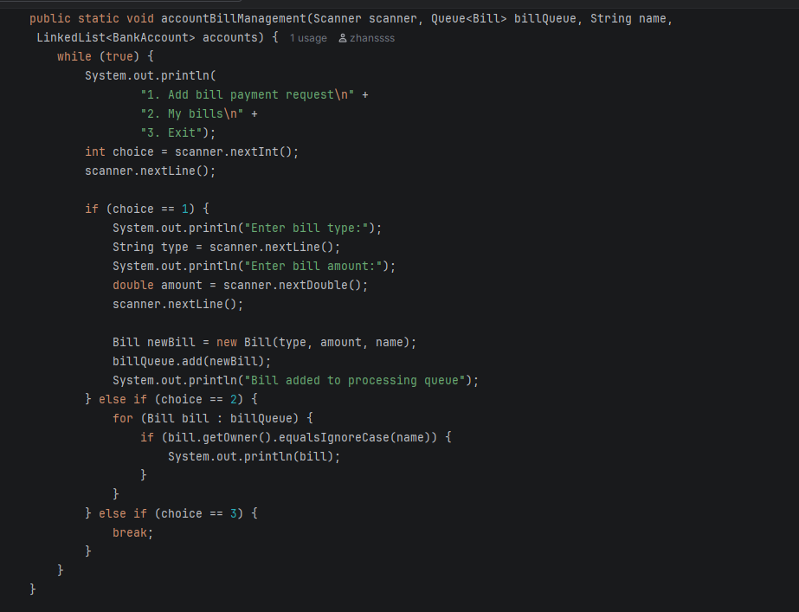

Created a billQueue using the Queue interface to handle payment requests. This ensures a fair First-In-First-Out (FIFO) processing order, where bills are settled by the admin in the order they were submitted.

Task 5 – Account Opening Queue (Admin Simulation)

Create Queue accountRequests.

User submits request → Admin processes queue.

Program must:

• Add account request to queue

• Process request (move to main LinkedList)

• Display pending requests

This simulates real banking workflow.
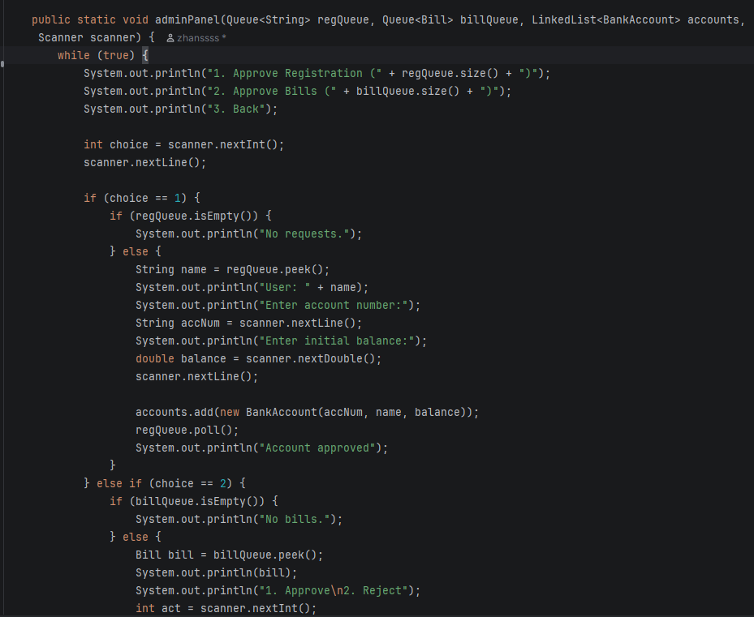
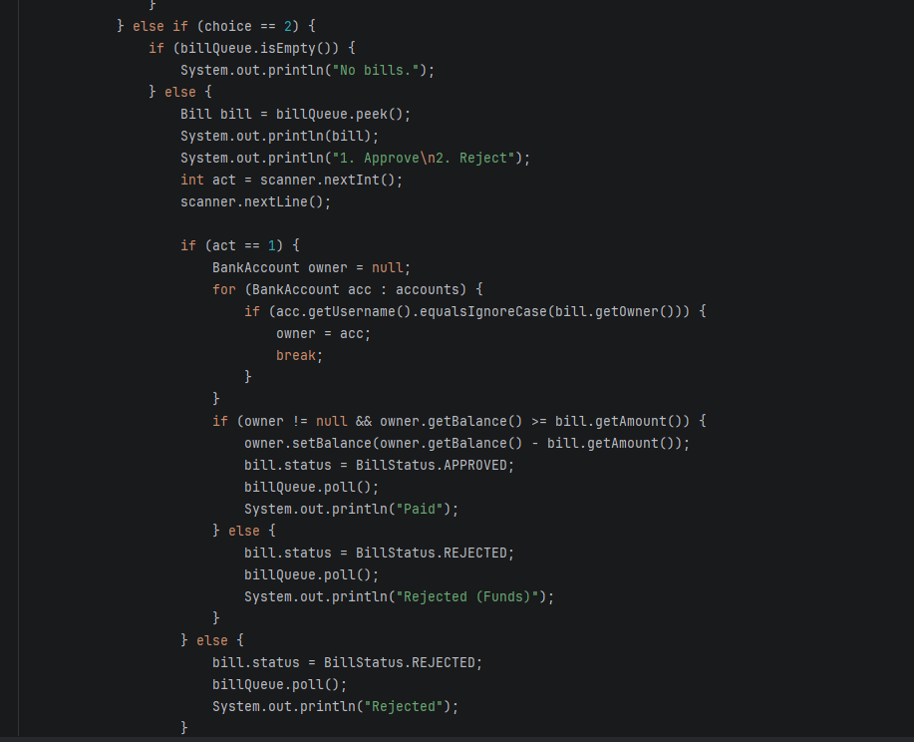
Designed a separate registrationQueue to simulate a realistic banking workflow. New account requests are held in a queue until an administrator approves them, at which point they are formally added to the main account storage.

Task 6. Create program that:
- Creates array BankAccount[3]
- Stores 3 predefined accounts
Prints them
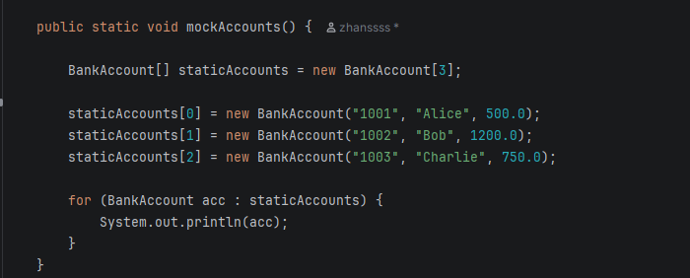

Implemented a fixed-size BankAccount[] array to store and display a set of predefined accounts. This task demonstrates the use of static memory allocation for a constant number of records.

